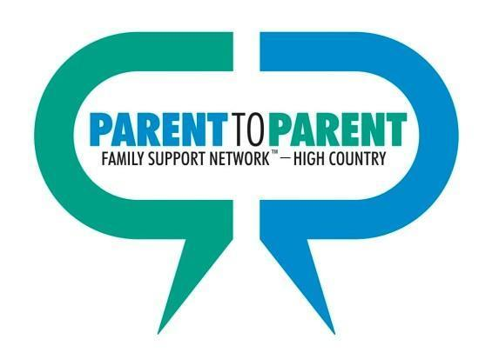

Dear Parents/Caregivers,
This notebook is a gift for you and your child from Parent to Parent Family Support Network™-High Country. This can serve as a way to document the care plan for all your child’s providers, help you keep your child’s medical information up to date, and assist you in keeping up with the different people involved in your child’s care. It will also help your child receive the best care from those who are providing the services.
In order for this book to be helpful to you and your child, we recommend using it to:
1. Share information with the care providers your child sees-even those that are not seen on a regular basis such as the emergency room or urgent care center.
2. Keep your child’s medical history organized, up to date and in one place.
3. Use the information in the IFSP/IEP/Preschool section to reflect on the IFSP/IEP process, your child’s individualized needs, and to prepare for your child’s IFSP/IEP..
4. Organize contact information of the people involved in your child’s care plan.
5. Write down any questions or concerns you or your child may have before seeing your doctors or other care providers, child care or school personnel or therapists.
This book is divided into tabbed sections with a list of what is in each section. There are helpful tips and information regarding resources in the community and state that may be of assistance to you as you plan for your child’s future. Feel free to make this notebook your own by adding, removing and moving pages around to fit your and your child’s needs.

We hope that this notebook helps you as you coordinate care for your child. You can access the forms at our P2PFSNHC website listed below. If you have trouble accessing the forms you need or believe our services would be helpful, please contact me and I will be glad to assist.
Sincerely,
Teresa Emory Outreach Coordinator-Avery, Mitchell & Yancey Burnsville, NC 28714 Phone: 828-284-2287 Provided with funding from: Email: emorytd@appstate.edu Toll free: 1-866-812-3122 www.parent2parent.appstate.edu

(Spring 2021)

